**“Sky High Watch Shop“**

Project Report Submitted In partial fulfillment for the award of

**Master of Computer Applications**

BY

**SHAIKH SLTAMASH**

MCA F.Y (SEM-1) 512127



Department of Master of Computer Applications

Jawaharlal Nehru Engineering College

Mahatma Gandhi Mission University, Aurangabad

(April-2021)

**PROJECT APPROVAL SHEET**

This project report entitled Mall on Wheels by Shaikh Altamash is approved for the partial fulfillment of the award of FYMCA degree of MGM University, Aurangabad (M.S.)

**Project In charge**

___________________________

**Prof. SujataS.Magare**

**External Examiner**

___________________________

___________________________

Date : / /

Place: MGM’s Jawaharlal Nehru Engineering College, Aurangabad. (M.S.) -431001

CERTIFICATE

This is to be certify that, the project work

**“Sky High Watch shop“**

Submitted by

SHAIKH ALTAMASH

Is a bonfire work completed under my supervision and guidance in partial fulfilment for award of Master of Computer Applications degree of MGM University, Aurangabad (M.S.) and is being submitted to MGM’s Jawaharlal Nehru Engineering College, Aurangabad.

**Prof. SujataS.Magare Dr.SonalS.Deshmukh**

Project Guide HOD MCA

Dr. H.H.Shinde

Principal

Jawaharlal Nehru Engineering College MGM

Aurangabad (M.S.)-431001

Declaration

I declare that this written submission represents my ideas in my own words and where other’s ideas or words have been included, I have adequately cited and referenced the original sources.

I also declare that I have adhered to all principles of academic honesty and integrity and have not misrepresented or fabricated or falsified any idea/data/fact/source in my submission.

I understand that any violation of the above will be cause for disciplinary action by the Institute and can also evoke penal action from the sources which have thus not been properly cited or from whom proper permission has not been taken when needed.

Guided By Student Name

Prof. Sujata Magare Shaikh Altamash

ACKNOWLEDGEMENT

The completion of any inter-disciplinary project depends upon cooperation, co-ordination and combined efforts of several sources of knowledge.

I wish to record my heartfelt gratitude and sincere thanks to my Guide Prof.Sujata R. Kondekar and Project in charge Prof. S.S.Magare Asst. Professor, Department of MCA, for their kind support, immense guidance and inspiration given till the end of my project.

I thank to Dr.Sonal S. Deshmukh, Head & Asst. Professor, Department of MCA, for their constant support and even willingness to give us valuable advice and direction.

I take this opportunity to extend my gratitude to Dr.H.H.Shinde Principal, Jawaharlal Nehru Engineering College,MGM University for their valuable suggestions.

Last but not least, I am also thankful to all the staff members for their immense cooperation and motivation of completing out the project

SHAIKH ALTAMASH

Index

|  |  |  |
| --- | --- | --- |
| SR NO. | Contents | Page No. |
| 1 | Introduction Purpose |  |
|  | Scope | 1 |
| 2 | Literature Survey Existing System |  |
|  | Proposed System  Advantages | 3 |
| 3 | System Requirement | 4 |
| 4 | Functional Requirements | 5 |
| 5 | E-R Diagram | 6 |
| 6 | Databases | 7 |
| 7 | System Design | 10 |
| 8 | Conclusion  Future Scope Limitation | 16 |
| 9 | Reference | 18 |

**INTRODUCTION**

* The project entitled “Mall on Wheels” enables customer to buy Mobile’s, Groceries, Fashion& Electronics from anywhere through online.
* This application advertises some of the products for shopping.
* To buy products, customer has to create an account.
* Those who does not have an account, they can only view products, he can also add the product to the cart and also he can place an order to buy those products.
* This application then generates bill for that particular customer.
* After the confirmation, the customer has to enter his debit or credit card details to buy those products.
* Online shopping is the process whereby consumers directly buy goods or services from a seller in real-time, without an intermediary service over the Internet
* It is a form of electronic commerce.
* An online shop, e-shop, e-store, internet shop, web shop, web store, online store or virtual store evokes the physical analogy of buying products or services at a bricks-and-mortar retailer or in a shopping Centre.
* Online shopping is the process of buying goods and services from merchants who sell on the Internet.
* The process of shopping done over the internet is called online shopping
  1. Purpose:

The purpose of this project is to make consumers available all the new arrivals of the products on the website www.ApniDukan.com. It will enable marketer to setup online shop, customer to browse through the shop and purchase them online without having to visit the shop physically.

The administration module will enable a system administrator to add and delete products and maintain the record of available products and purchases.

* 1. Scope:

Mall on Wheels is a website which will help the user to buy different products online. Online Mall provides number of choices, and it reduces the manual effort of the consumer.

* We will provide the best products of various companies.
* Our website will be available 24×7 for the ease of user.
* Our primary objective is to facilitate the customer. Through online shopping he will save a lot of time.
* The bank details provided by the customer will be highly confidential.
* We will provide the e-mail facility for further correspondence.
* We will maintain database for different users.
  1. Intended audience and document overview:

The intended audience of this site is admin and the consumers. The review can be given by the consumers who buy the product.

* 1. Technology for project:

The technology used for project are:

* HTML
* CSS

1.5 Database:

My SQL

**2. Literature survey**

2.1 Existing system:

* Lack of Communication between buyers and sellers.
* To buy any product user has to collect information about it either by visiting the shop or asking people which is the better one.
* Customers need to personally go to shopping site, check their products, place an order and pay the bill upon receiving their product.

2.2 Proposed system and its needs:

* East to handles.
* Customers can see the product items.
* Customers can order the products.
* Cash on delivery service.
* Delivery on proper address.

2.3 Advantages:

* Convenience of online shopping. Customers can purchase items from the comfort of their own homes or works place.
* No pressure shopping.
* Online shopping saves time.
* Comparisons.
* Availability of online shop.

**3.SYSTEM REQUIREMENT**

**Hardware Requirement:**

* + RAM: 516MB
  + Hard Disk: 2GB
  + Processor: Intel (R) Core(TM) i3

**Software Requirement:**

* + Operating System: Windows 7
  + Frontend: HTML, CSS
  + Backend: PHP, MYSQL

|  |  |
| --- | --- |
|  |  |
| Browsers: | Chrome. |
| Tools used: | XAMPP, |
|  | Visual studio. |
|  |  |
|  |  |

4.Functional Requirements:

This section provides requirement overview of the system. Various functional modules that can be implemented by the system will be –

**Registration:**

If customer wants to buy the product then he/she must be registered, unregistered user can’t go to the shopping cart.

**Login:**

Customer logins to the system by entering valid user id and password for the shopping.

**Changes to Cart:**

Changes to cart means the customer after login or registration can make order or cancel order of the product from the shopping cart.

Nonfunctional Requirements:

Following Non-Functional Requirements will be there in the insurance to the internet:

* Secure access to consumer’s confidential data.
* 24X7 availability.
* Better component design to get better performance at peak time.
* Flexible service based architecture will be highly desirable for future extension.
* Non-Functional Requirements define system properties and constraints.

# 5. E-R Diagram:

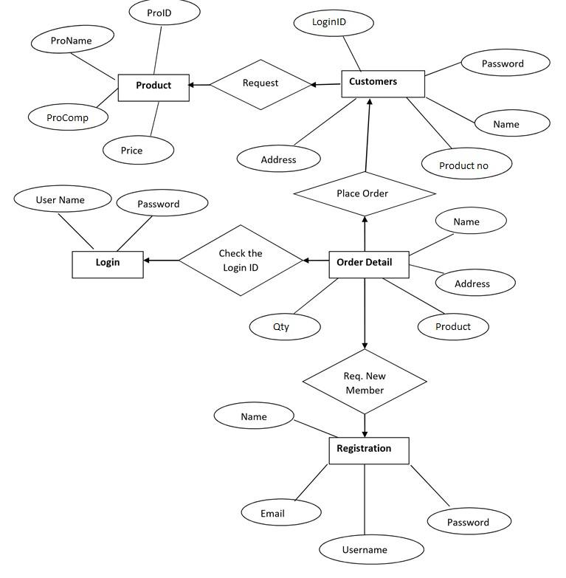

**6. Database:**

**1. Admin:**

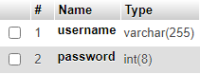

# 2. Customer:

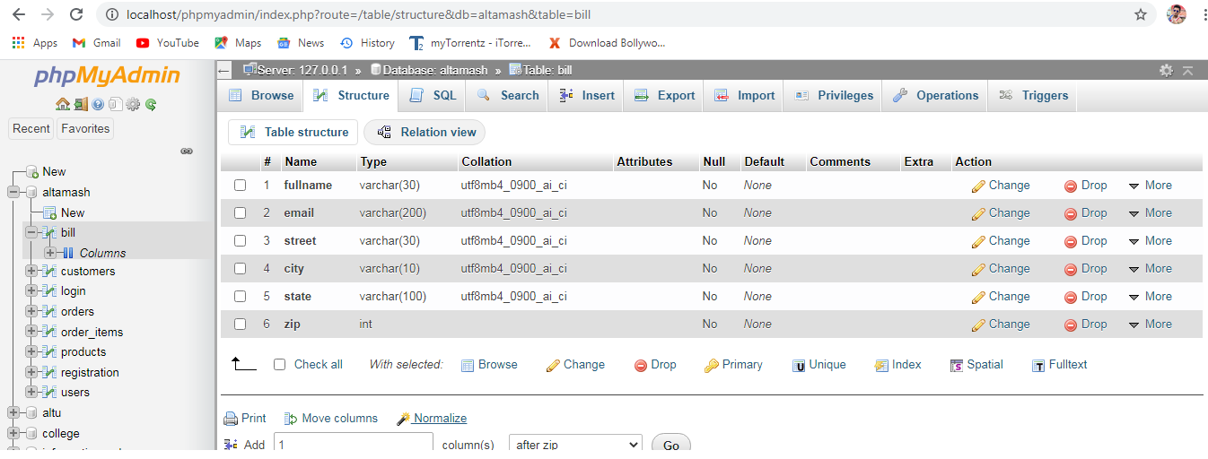

# 3. Customer Login:

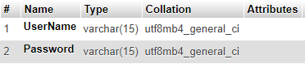

# 4. Orders:

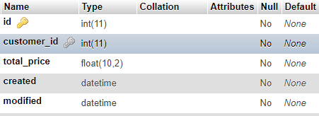

# 5.Order_items:

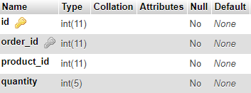

# 6. Products:

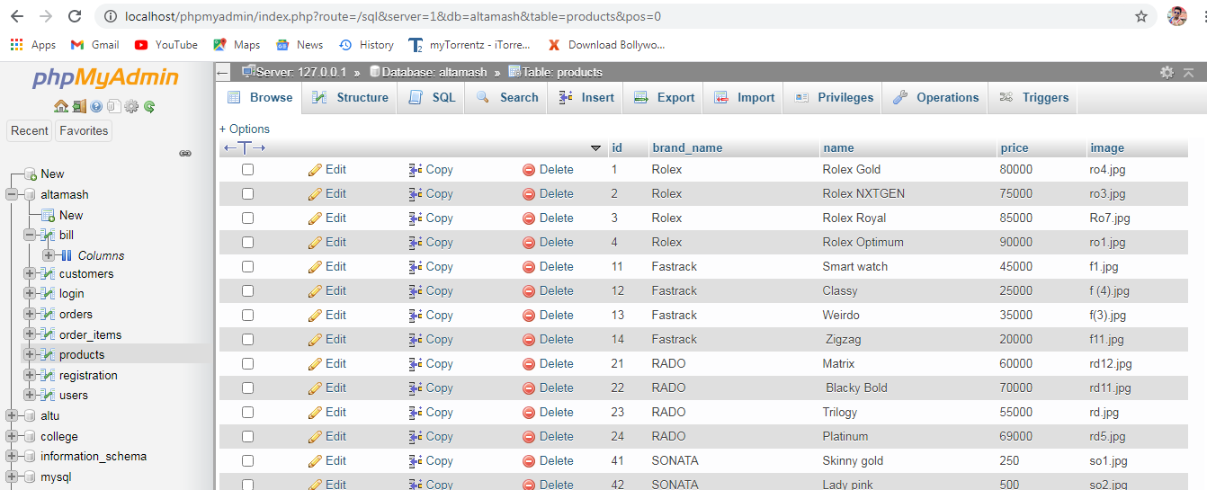

# 7.Register:

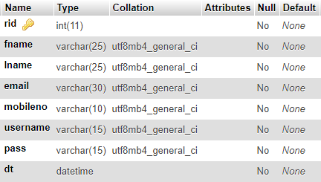

# 

# 7.System Design:

**7.1 Login page:**

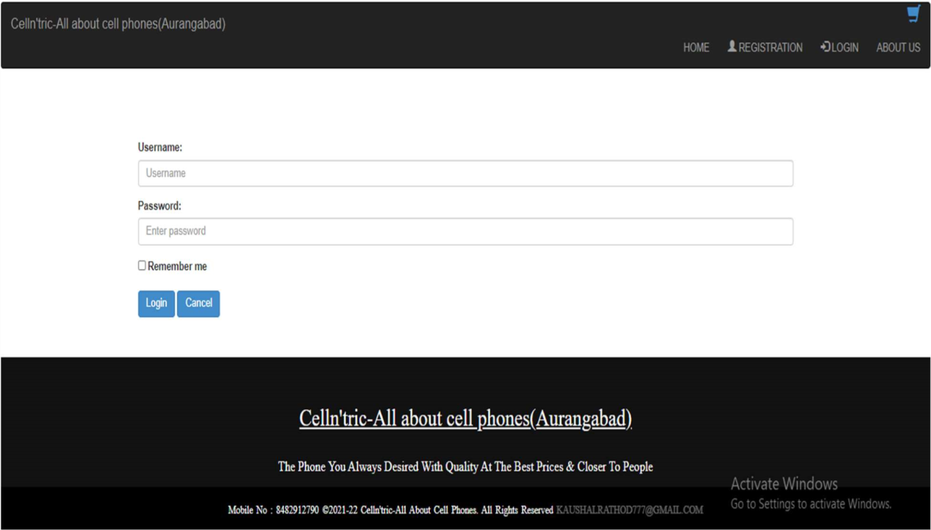

Home Page

Add to cart:

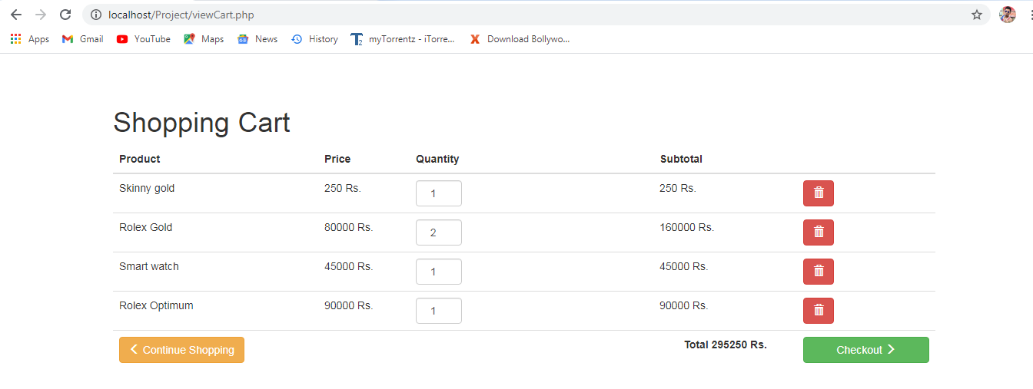

Shipping Details:

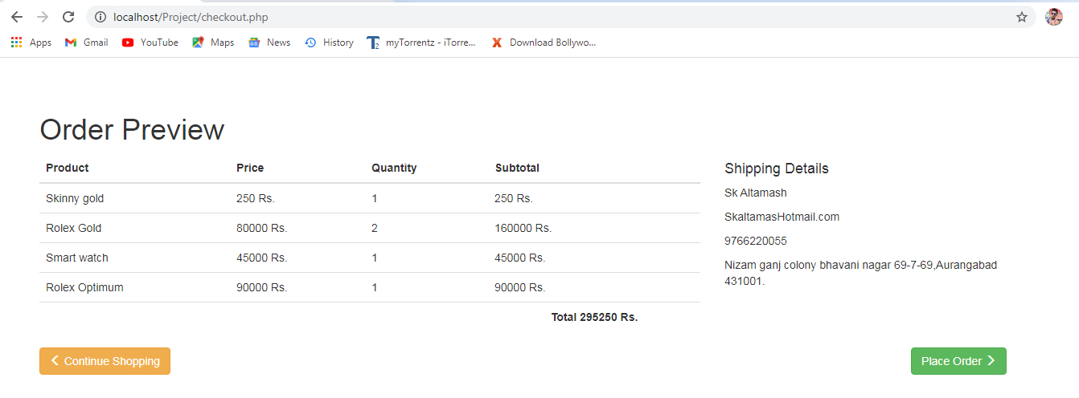

Order Confirmation:

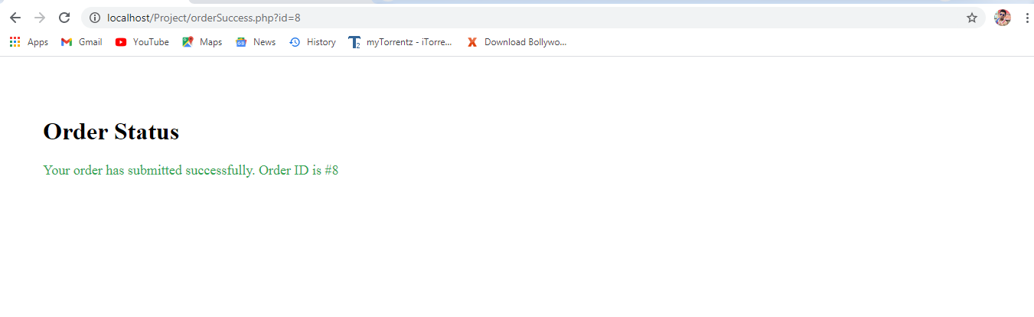

## 

# 8.Conclusion

The project entitled “Mall on Wheels” is developed using ASP.Net as front end and SQL Server database in back end to computerize the process of online buying and selling of products in a mall. This project covers only the basic features required.

However a lot of features are already incorporated in this project. The main beneficiaries are both customers as well as ADMIN who consume more time while dealing with products. Moreover extra features can be identified and incorporated in the future

In order to accommodate additional features it will take longer time and effort to understand the requirement and converting it into computerized system.

# 9.Future scope of the project:

Mall on Wheels is a website which will help the user to buy different products online.Mall on Wheels provides number of choices and it reduces the manual effort of the consumer.

* We will provide the best products of various companies.
* Our website will be available 24x7 for the ease of user.
* Our primary objective is to facilitate the customer. Through online shopping he will save a lot of time.
* The bank details provided by the customer will be highly confidential.
* We will provide the e-mail facility for further correspondence.
* We will maintain database for different users

**10.Limitation**:-

The “Mall on Wheels“has some flows and limitation due to different requirements and time constrain. This project provides only the basic functionalities of e commerce. Several of it limitation is:

* There may be chances of security breaches and sql injection as we are still in process of studying them and methods to prevent them.

We tried our best to save the customer’s data.

* To save passwords stored in the database, we have stored its hash value. So, the administrator will also not know about the password. But still there are chances of security breaches with the help of rainbow tables.
* We assume that user has prior knowledge about the interface and computer.
* This project lacks validation of forms at various places.
* Currently only one item’s information can be entered in the system at a time.

# 11.References:

* www.bootstrap.com
* www.fontawesome.com
* www.w3school.com/html
* www.googlefonts.com
* https://www.tutorialpoint.com/mysql/